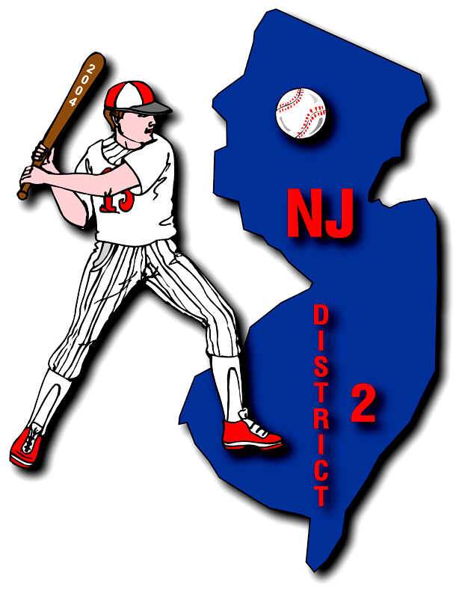
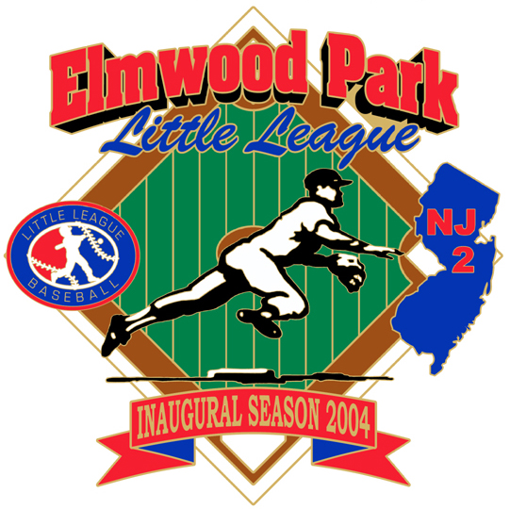


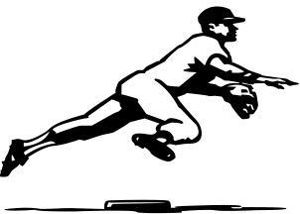

2019 LEAGUE SAFETY PLAN

Safety Director: Joe Marsh
Version 14.0



Table of Contents

Table of Contents ………………………………………… 2

Safety Director Welcome Statement …............................ 3

Elmwood Park Boro Emergency Phones #’s ………... 4

Elmwood Park LL Phone Listing ................................... 5a/b

Field Inspections …………………………………………. 6

Codes of Conduct
Directors & Officers …..………………………………………. 7
Players ……………………………………………………….. 8
Coaches ……………………………………………………… 9
Parents/Volunteers ……………………………....................... 10
Information
Hydration ……………………………………………… 11
Nutrition ………………………………………………. 12-15
Player Fitness …………………………………………. 16
Stretching Positive/Negatives ………………………… 17
Baseball Coach Health Tips ………………………….. 18
Transportation ………………………………………… 19
Psychology of Keeping Youth Sports Fun …………… 20
Preventing Children’s Sports Injuries ………………… 21-24
Treating Sport Injuries ………………………………… 25
Safety Code
What is ASAP? ………………………………………... 26
Safety Focus …………………………………………… 26
Safety Tips …………………………………….............. 27
Do’s & Don’ts …………………………………………. 28

Lightning & Storm Safety ……………………………….. 29

Concession Guidelines ………………………………….. 30

Accident Reporting Policy ………………………………. 31

Safety Mission Statement ……………………………….. 32

Elmwood Park Field Listings
Boro Field …………………………………………….. 33
Juniors/ Seniors Field …………………………............ 34
Gilbert Fields ………………………………................. 35
Gall Ave Field ………………………………………... 36
Appendix
A …………….... 2015 Field Survey ……………........ 37-41
B ………… Volunteer Form Returning Vol Form… 42a/b
C ……… Player Registration Form …………………. 43
D ……. Player Medical Release Forms ……………… 44
E ………….. Incident & Injury Forms ……….............. 45-46
F ………….. Internet Photo Parent Consent …….............. 47
G .……………... Coaches Clinics .......………………… 48

Safety Director’s Welcome Statement

January 1, 2018
Managers and Coaches:

As Safety Director I would like to personally welcome you to the “2018 Season” of the Elmwood Park Little League”.

This is the Official Elmwood Park Little League Safety Manual. Please take some time to read it and become familiar with all the contents. It may be used as a resource tool throughout the season. Elmwood Park Little League’s Board of Directors is not only committed to the safety and well being of every player, but the managers, coaches, volunteers, and spectators that participate in the program.

The following are some of the initiatives of the EPLL for the “2019 Season:

- The attached updated and complete 2019 Safety Manual will be available on the website for future reference. The Website can be found at:
www.eplittleleague.com
- The Safety Director is an Official member of the Elmwood Park Board of Directors, and will be available at any time for Safety Questions or Inquiries.
- First Aid Kits and Ice Packs have been made available to each Manager.
- All Directors, Managers, Coaches, and Volunteers will complete the 2018 Volunteer form that will be kept on file at the League Headquarters. These forms will be utilized to do the “mandatory” annual background checks that Williamsport is now requiring. Copies of this form can be found in the “Appendix B Section of the Manual”.
- Municipal requirements mandate that all Volunteers must be finger printed and the fees are reimbursable by the Boro of Elmwood Park.
- Managers and Coaches must be certified via the Rutgers S.A.F.E.T.Y (Sports Awareness For Educating Today’s Youth) Clinic Course. Any new coaches that need to become certified may contact Safety Director Joe Marsh at (862)219-8466 and arrangements will be made with a facilitator.
- All accidents must be documented and reported to the Safety Director. This will be explained in length in the Accident Reporting Policy Section.
- Before distribution to Team Managers, all Equipment was evaluated for the utmost Safety. Any damaged or worn equipment discarded and replaced.
- Online Registration is active 2018 for the EPLL. Visit the EPLL Website for more information

To summarize, safety is of the utmost importance to ensure that the children that are competing are surrounded by a safe and healthy environment. Common sense more often comes into play, so keep that in mind, so “play hard and play safe”!

Respectfully Yours,
Joe Marsh Elmwood Park Little League Safety Director

Elmwood Park Boro
Emergency Phone Numbers

Police


911 or
201-796-0700

Ambulance


201-796-0700

2019
Elmwood Park
Little League Phone Listing

2019 EPLL Officers Phone List

Manny Perez | President |  | 201-306-2081
Neil McKenna | Vice President |  | 551-906-9123
Aldo Sayegh | Treasurer |  | 973-768-2078
Dave Rhodes | Secretary |  | 201-893-3407
Anthony Morales | Player Agent |  | 201-206-0955
Jeff Leider | Sponsorships/ Fundraisers |  | 201-647-5465
Brandon Rivera | Website Administrator |  | 201-417-7589
RJ Calabro "Omaha" | Field Maint/Score Keeper |  | 201-797-8311
Joe Marsh | Safety Director |  | 862-219-8466
Gayle McKenna | Concession Stand Coordiantor |  | 551-206-9122
Neil McKenna | Equipment/Apparel Coordinator |  | 551-906-9123

Elmwood Park Little League 
Field Inspections

Regular safety inspections of the field, permanent and temporary structures, ball playing equipment and personal protective equipment is the best way to determine which unsafe conditions require correction. The managers, coaches, and League Officials should work together to insure serious accident exposures are corrected promptly! It is good experience and safeties training to have the youngsters take part in the procedure.

The following list will be of assistance in determining conditions that
cause accidents.
- Prompt action must be taken on all serious hazards.
- Unsafe field conditions such as holes, ditches, rough or uneven spots, slippery areas and long grass.
- Foreign objects like stones, broken glass, old boards, pop bottles, rakes, etc.
- Incomplete or defective screen, including holes, sharp edges and loose edges.
- Wire or link fencing should be checked regularly for similar defects which could injure a participant.
Board fences should be free of protruding nails, loose boards, and splintered wood.
- The warning track should be well defined and not less than 10 feet wide.
- Bat rack and on-deck circle should be behind the fences.
- The Protective Screen to the sides of the backstop must be securely fastened to the fence at all times.
- The backstop should be padded and painted green for the safety of the catcher.
- The dugout should be clean and free of debris.
- Dugouts and bleachers should be free of protruding nails and wood slivers.

- See Appendix A for current “2018 Field Survey”.
Code of Conduct
Directors & Officers
- I will treat all children with respect, being positive and constructive at all times to all players and umpires.
- I will not use abusive language or actions and will control my anger at all times. I will insist that any parents, coaches, players, and/or fans that I come in contact with follow my example.
- I will continuously strive to improve the operations of the League and be pro-active in seeking improvement and change, if necessary, in my primary area of responsibility as a Board member.
- I will solicit the opinions of other Board members, coaches, and parents (where applicable) in order to constantly evaluate the League’s progress toward its stated goals.
- I will monitor the behavior of the League’s teams and coaches and when I am present at a League sponsored event I will take action as necessary to assure the proper conduct of all present. Whenever possible or appropriate, I will attend League sponsored clinics to lend support to the League’s instructional programs.
- I will promote sportsmanlike conduct, by all those present at League sponsored events, including shaking hands between coaches after each game, encouraging team members to cheer positively and shake hands with the other team in a sportsmanlike manner after the game, and positive support for all players and umpires by the fans. I will not tolerate negative cheering, trash-talking or displays of anger or disrespect by any player, coach, umpire, fan, or team.
- I will not seek to manipulate drafts, tryouts or League rules to achieve an unfair advantage for myself or any other coach, team, or group of players within the League.
- I will not smoke or drink alcoholic beverages at the fields.
- I will enforce all players to wear a protective cup during practices and games.

Code of Conduct
Players
- I will have respect for the equipment
- When at bat, I will always wear my helmet and will not remove it until I return to the dugout.
- As a player, I will always wear the proper equipment as provided and recommended by the league.
- I understand that it is mandatory for me to wear a protective cup during practice and games.
- I will always wear the proper uniform in the proper way.
- I will not allow myself to display anger directed at an opposing player, coach, umpire, teammate or myself.
- I understand that I will be ejected from the game for this type of behavior.
- I understand that if I intentionally throw my bat, helmet, glove or any piece of equipment that I will be subject to ejection from the game at the discretion of the umpire.
- I will try to be responsible while at bat and not throw my bat unintentionally. If I do, in most cases a warning will be issued. Any subsequent offense will result in an out or ejection at the discretion of the umpire.
- I will play hard but in a safe and responsible manner. I will not intentionally endanger another player in any way.
- I will not use abusive language or participate in any form of trash talk or negative cheering.
- I will promote sportsmanlike conduct, encouraging my team members to cheer positively and shake hands with the opposing players after each game.

Code of Conduct
Managers & Coaches
- I will treat all children with respect, being positive and constructive at all times to all players and umpires.
- I will not use abusive language or actions and will control my anger at all times.
- I will insist that parents and members of my team follow my example.
- I will strictly enforce the rule that all players must wear a protective cup during practices and games.
- I will continuously improve my baseball coaching skill by attending League-sponsored coaching clinics to the best of my ability (outside clinics are encouraged as well).
- I will have registration/medical release forms and a first aid kit on hand whenever my team is together.
- I will treat all umpires with respect, and that baseball rules involve judgment. If I have complaints, I will use the appropriate methods of appeal during the game avoiding confrontational behavior on the field. After the game I may go through the proper channels for resolution.
- I will monitor the behavior of my team's parents in the stands and will take action as necessary to assure proper conduct.
- I will promote sportsmanlike conduct, shaking hands with the opposing coach after each game, encouraging my team member to cheer positively and shake hands with the other team in a sportsmanlike manner after the game as well. I will not tolerate negative cheering, trash-talking or displays of anger or disrespect by my team.
- I will conduct regular practices that will be used to teach sound baseball fundamentals while being fun for all involved. Unless parents approve of their child leaving practice on their own, I will be sure that an adult is present until every player has been picked up after practice.
- I will not seek to manipulate drafts, tryouts or league rules to achieve an unfair advantage for my team
- I will not smoke or drink alcoholic beverages at the fields.

Elmwood Park Little League
Parent/Volunteer
Code of Conduct

- I will treat all participants with respect, being positive and constructive at all times to all players and coaches. I will not use abusive language or actions and will control my anger at all times.
- I will treat all umpires with respect, recognizing that they are volunteers or young adults, and that baseball rules involve judgment.
- I will not openly criticize the umpires during the course of the game.
- If I have concerns about players, coaches, umpires, fields or any other aspect of EPLL, I will direct them to a League Director away from the field.
- I will cheer positively providing encouragement for members of both teams.
- During the game I will remain in the stands, away from the dugouts, and off of the field unless requested by the coach to give assistance to an injured player.
- I will support my child's commitment to his team by assuring his/her regular attendance at practices and games.
- I will abide by the Good Neighbor Policy, parking only in approved areas at all fields.
- I will not smoke or drink alcoholic beverages at the fields.

Players Name (print)

Parent Name (print)

Parent Signature

Date:
HYDRATION 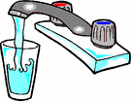

Remember that drinking water is an essential part of top performance as well as for hydration! Sometimes the most important nutrient children need is water, especially when they’re physically active. When children are physically active, their muscles generate heat thereby increasing their body temperature as their body temperature rises, their cooling mechanism sweat kicks in. When sweat evaporates, the body is cooled.

Unfortunately, children get hotter than adults during physical activity and their body’s cooling mechanism is not as efficient as adults. If fluids aren’t replaced, children can become overheated.

We usually think about dehydration in the summer months when hot temperatures shorten the time it takes for children to become overheated. But, keeping children well hydrated is just as important in the winter months. Additional clothing worn in the colder weather makes it difficult for sweat to evaporate, so the body does not cool as quickly. It does not matter if it’s January or July thirst is not an indicator of fluid needs. Therefore, children must be encouraged to drink fluids even when they don’t feel thirsty.

Managers and coaches should schedule drink breaks every 15 to 30 minutes during practices on hot days, and should encourage players to drink between every inning. During any activity water is an excellent fluid to keep the body well hydrated. Offering flavored fluids like sport drinks can help encourage children to drink. Sports drinks should contain between 6 and 8 percent carbohydrates (15 to 18 grams of carbohydrates per cup) or less. If the carbohydrate levels are higher, the sports drink should be diluted with water. Fruit juice should also be diluted (1 cup juice to 1 cup water). Beverages high in carbohydrates like undiluted fruit juice may cause stomach cramps, nausea and diarrhea when the child becomes active. Caffeinated beverages (tea, coffee, hot chocolate) should be avoided because they are diuretics and can dehydrate the body further. Avoid carbonated drinks which can cause gastrointestinal distress and may decrease fluid volume.

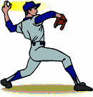 Nutrition 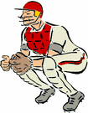
Just as a car runs best with a full tank of fuel, your body can only reach its peak performance level when you give it the right kind of "nutritional fuel." Eating well for your sport can be very simple and you do not need to buy special foods or supplements! To make sure that you are in top form, all you have to do is follow the Food Guide Pyramid.
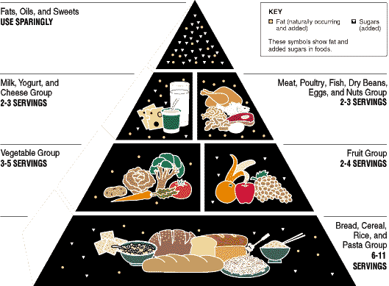
By eating foods from the five different food groups in the Food Guide Pyramid, you will get the nutrients you need to keep your body fit and strong. The Food Guide Pyramid was created to meet the nutritional needs of active people. If you are a teen athlete your body needs lots of servings of all the Pyramid foods (grains, fruits, veggies, dairy, proteins and fats).
You need to make sure that you are fueling your body with carbohydrates, proteins, fats, minerals, vitamins, and water. A diet high in carbohydrates or "carbs" (pasta, bread, cereal, rice, fruits, and certain vegetables) is especially important for athletes because carbs supply the body with glucose (blood sugar) for energy.
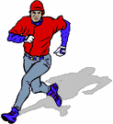 Nutrition con’t 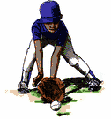
The extra glucose is stored in the muscles and liver as "glycogen," your energy reserve. During short bursts of exercise such as basketball, gymnastics or soccer, your body uses mostly stored glycogen from the muscles (and glucose released from the liver glycogen) for energy. If you don't have enough glycogen you can feel very tired, which will affect your athletic performance. With longer exercise or endurance exercise such as cycling or long distance running, your body uses the glycogen stores first and then uses fats stored in your body to fuel performance. Protein is necessary to build and repair muscles but gives you only a small amount of the energy. Minerals and vitamins such as calcium and iron are needed for strong bones and blood cells, but do not provide energy. Athletes should eat a balanced diet with a variety of foods, and make sure they are getting the right amount of vitamins and minerals, but high doses of vitamins do not improve performance and can be dangerous.
The Three Basic T's to Healthy Eating
- Type: There is no single magic food that has all the nutrients your body needs. Different foods offer different nutrients. For example, oranges provide vitamin C and carbohydrates but not iron or protein. Beef offers iron and protein but not vitamin C or carbohydrates. In order for your body to be in peak condition, you need to eat a variety of foods.
- Total: It is important that you are eating enough calories to fuel your body for exercise and to replace energy that is lost during competition. Cutting calories and carbs keeps you from performing at your best. You’re training demands energy and if you want to compete at full strength you need to meet your body's energy needs.
- Timing: Knowing how to "fuel" your body the right way before and after exercise will keep you in top form. Skipping meals will weaken your performance but eating regular meals and healthy snacks will give your body the best fuel for athletic events.

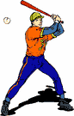 Nutrition con’t 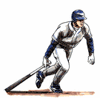
The food you eat before you exercise greatly affects the quality of your athletic performance. These tips will help you to plan your pre-exercise meals so that you won't feel hungry and so your muscles will be properly fueled for training and competition:
- Eat a larger meal if you have 3-6 hours before you begin your exercise. Smaller "mini" meals are better if you only have an hour or two before your workout begins. Meals that are high in complex carbohydrates (foods rich in carbohydrate that have long lasting energy power) are powerful because they give your muscles the very best source of fuel. Pasta, bagels, baked potatoes, rice, and fresh fruit are all good sources of complex carbohydrates.
- Avoid high-bulk (high-fiber), gas forming foods such as broccoli, baked beans, or bran cereal. These foods may cause gas pains during exercise.
- Avoid sugars and sweets, especially soft drinks and candy, less than 1 hour before training. High-sugar foods will give you quick energy, but they won't last long enough.
- Limit the amount of fatty foods such as eggs, meat, and cheese that you eat for your pre-exercise meal. These foods take much longer to digest and may make you feel sluggish and tired.
- Do not try new foods before a competition. You may have trouble digesting a food you have never eaten before. Choose foods that you eat regularly and are familiar to you.
- Drink 16-20 ounces of fluids (2 to 2½ 8 oz. glasses) 2-3 hours before you begin exercising. You should drink another 7-10 ounces of water or sports drink 10 to 20 minutes before exercising. Make sure that your water bottle is a regular part of your sports equipment!

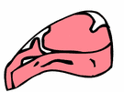
Nutrition con’t
Hours Before Exercise | What to Eat-some ideas | What to Drink-some ideas
1-2 Hours - Snack | Fresh Fruits or  Vegetables (low fiber)  Crackers, Granola or  Cereal Bars | Water  Fruit or Veggie Juices,  Sports Drinks
2-3 Hours - "Mini" Meal | Fruits, Vegetables,  Breads, Bagels,  More Crackers, Cereal | Water  Fruit or Veggie Juices,  Sport Drinks
3 or More Hours - Larger Meal | Fruits, Vegetables,  Breads, Bagels,  Peanut Butter, Lean Meat, Cheese, Yogurt,  Cereal with Milk, Baked Potato | Water  Fruit or Veggie Juices,  Sport Drinks

After a hard workout, it is very important that you refuel your body with the carbohydrates and fluids you used during your workout. Your body replaces the glycogen energy stores in the muscle within the first few hours of exercising. That's why it is important to eat carbohydrates and drink fluid soon after your workout.
It's hard to know exactly how much food and fluid your body will need for top athletic performance. As you follow this guide you will know when your body is getting all the energy it needs because you will feel good and have the energy it takes to play your sport well.
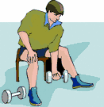 Player Fitness 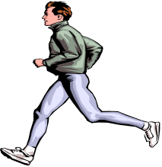
One of the misconceptions in the sports world is that a sportsperson gets in shape by just playing or taking part in his/her chosen sport. If a stationary level of performance, consistent ability in executing a few limited skills, is your goal then engaging only in your sport will keep you there. How ever, if you want the utmost efficiency, consistent improvement, and balanced abilities sportsmen and women must participate in year round conditioning programs. The bottom line in sports conditioning and fitness training is stress. Not mental stress, but adaptive body stress. Sportsmen and women must put their bodies under a certain amount of stress to increase physical capabilities.
Definition of Fitness - Exercise scientists have identified nine elements that comprise the definition of fitness. The following lists each of the nine elements and an example of how they are used:
- Strength - the extent to which muscles can exert force by contracting against resistance (holding or restraining an object or person)
- Power - the ability to exert maximum muscular contraction instantly in an explosive burst of movements (Jumping or sprint starting)
- Agility - the ability to perform a series of explosive power movements in rapid succession in opposing directions (Zig-Zag running or cutting movements)
- Balance - the ability to control the body's position, either stationary (e.g. a handstand) or while moving (e.g. a gymnastics stunt)
- Flexibility - the ability to achieve an extended range of motion without being impeded by excess tissue, i.e. fat or muscle (Executing a leg split)
- Local Muscle Endurance - a single muscle's ability to perform sustained work (Rowing or cycling)
- Cardiovascular Endurance - the heart's ability to deliver blood to working muscles and their ability to use it (Running long distances)
- Strength Endurance - a muscle's ability to perform a maximum contracture time after time (Continuous explosive rebounding through an entire basketball game)
- Coordination - the ability to integrate the above listed components so that effective movements are achieved.

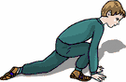 Stretching 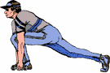
Positives & Negatives

+ Positives
- Use slow, static stretching techniques in which the muscle is stretched at the end of its range of motion. A good approach is to "stretch to the point of slight discomfort and hold this position."
- Include at least one exercise for each major muscle group of the body in a flexibility program.
- Warm up sufficiently before stretching, as "cold" muscles are easily torn and damaged. Light aerobic exercise and sport specific activities are recommended as appropriate warm-up exercise.
- Incorporate stretching exercises into a "cool-down" routine, as active cool-downs aid in muscle recovery and prevent muscle soreness.

- Negatives
- Perform ballistic stretches (jerky, bouncing motion) because they increase the chances of tearing tendons and muscle fibers.
- Perform stretches which may compress bony structures, nerves, or cartilage.
- Use partner stretching exercises, as joints are typically forced beyond their normal range of motion, increasing the potential for injury.
- Stretch sprained ligaments or strained muscles and tendons, as re-injury can occur quite easily.
10 Health Tips Every Youth 
Baseball Coach Should Know
- Stretching the muscles related to the activity is very important. For example, if a child is pitching, he should concentrate on stretching his arm and back muscles. If a child is catching, the focus should be on the legs and back.
- A good warm-tip is just as important as stretching. A warm-up can involve light calisthenics or a short jog. This helps raise the core body temperature and prepares all the body's muscles for physical activity.
- Children should not be encouraged to "play through pain." Pain is a warning sign of injury. Ignoring it can lead to greater injury.
- Swelling with pain and limitation of motion are two signs that are especially significant in children -- don't ignore them. They may mean the child has a more serious injury than initially suspected.
- Rest is by far the most powerful therapy in youth sports injuries. Nothing helps an injury heal faster than rest.
- Children who play on more than one team are especially at risk for overuse injuries. Overuse injuries are caused by repetitive stress put on the same part of the body over and over again.
- Injuries that look like sprains in adults can be fractures in children. Children are more susceptible to fractures, because their bones are still growing.
- Children's growth spurts can make for increased risk of injury. A particularly sensitive area in a child's body during a growth spurt is the growth plate -- the area of growth in the bone. Growth plates are weak spots in a child's body and can be the source of injury if the child is pushed beyond his limit athletically.
- Ice is a universal first-aid treatment for minor sports injuries. Regular ice packs -- not chemical packs -- should be available at all games and practices. Ice controls the pain and swelling caused by common injuries such as sprains, strains and contusions.

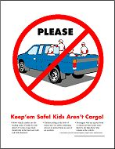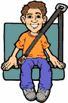
Transportation

Before any manager or designated coach can transport any child, other than his/her own, anywhere, he or she must:

- Have a valid New Jersey State License.
- Wear corrective lenses when operating a vehicle if the Driver’s License stipulates that the operator must wear corrective lenses.
- Have correct class of license for the vehicle he or she is driving.
- Not carry more children in their vehicle than they have seat belts for.
- Make sure that the vehicle is in good running order and that it would pass a NJDMV Vehicle Safety Inspection if spontaneously given.
- Not drive in a careless or reckless manner.
- Not drive under the influence of alcohol, drugs, or medication
- Obey all traffic laws and speed limits at all times.
- Never transport a child without returning him/her to the point of origin.
- Have parental permission to transport player. If it is on a permanent basis it may be pertinent to have the parent sign a parental waver.


Psychology 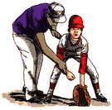 Keeping Youth Sports Fun
The number of youths that are participating in sport is on the rise. Children as young as five are participating in one or more sports offered in a variety of organized programs available at the club, community, and school levels for youths. Adults who are involved in youth sports as coaches, officials, league administrators, and educators should understand that the main reason children are drawn to sport is to have fun. Therefore, adults should try to structure the sport environment so that the children enjoy their sport experience. For example, allow children to choose which position they would like to play during a practice or to play without keeping score. Also teaching the basic fundamental skills through non-competitive game - like drills is recommended. Although winning and losing is part of organized sport, a focus on outcomes rather than performance can be detrimental. When children lose, some may feel like a failure and perceive themselves to have less ability than others. Children should be told that their effort during practice and/or competition is under their control and that they do not have to win in order to have a successful performance. Coaches and parents need to help children learn that the outcome is not the most important thing. Adults should help children realize that personal achievements and the child's individual effort are more important than the outcome. High effort and the accomplishment of personal goals can provide a sense of success for the child. In order to help children cope with losing, parents and coaches need to focus their attention on other aspects of the competition instead of the outcome. Helping children develop a positive self-concept and self-confidence is important. After youngsters lose, they need to be reassured that they are not less important and that it is their effort and personal achievements that are most important. After a competition, instead of talking to young athletes about what went wrong in the game, communicate what was done right. If a softball team loses but had no base running mistakes, the youngsters should be complimented on their base running. Telling children what they did right will enhance their self-confidence and motivate them to work for improvements. Coaches should always treat all athletes equally. If a child is ignored by the coach or does not play a lot, their self-confidence will go down. Every child needs to be given equal attention and playing time to decrease their feelings of inadequacy. The feeling of inadequacy can result in a low level of effort for a game and can eventually lead to the child dropping out of the sport. With youth sport becoming increasingly popular, coaches and parents need to help children learn how to deal with a loss in a way that self-confidence does not suffer. By focusing on the effort displayed and personal achievements instead of outcomes, children will learn that hard work and determination will help them to eventually create the outcomes that they want. Finally, remember to treat each child equally and make sure that children are having fun. Efforts by adults designed to help children to enjoy their sport participation will help to keep kids in sport longer.
 Preventing Children’s Sports injuries 
Your sports-loving children may not be Olympic or professional athletes, but that doesn't mean they aren't at risk for getting hurt. Participation in any sport, whether it's recreational bike riding or peewee football, teaches children to stretch their limits and learn the value of sportsmanship and discipline. However, any sport that your child participates in carries the potential for injury.
According to the National SAFE KIDS Campaign:
- more than 30 million kids participate in organized sports in the United States, and still more children participate in recreational activities such as bicycling, in-line skating, riding scooters, and skateboarding
- approximately 775,000 children are treated in hospital emergency departments for sports-related injuries
- about 25% of these injuries are considered serious
By knowing the causes, prevention, and treatment of sports injuries, you can help make athletic participation a positive experience for your child.
- What Causes Sports Injuries Among Children?
Kids are more susceptible to sports injuries for a variety of reasons. Children are less coordinated and have slower reaction times than adults because they are still growing and developing. In addition, children mature at different rates. Therefore, a substantial difference in height and weight between children of the same age can exist. When children of the same age but varying sizes play sports together, there may be an increased risk of injury.
As children grow bigger and stronger, the potential for injury increases, largely because of the amount of force involved. For example, a collision between two 8-year-old peewee football players who weigh 65 or 70 pounds each does not produce as much force as that produced by two 16-year-old high school football players who may each weigh up to 200 pounds. Children younger than age 10 are more likely to be injured on playgrounds or sledding hills, whereas injuries due to organized sports or overexertion tend to occur more frequently in older children.
Finally, children are less likely to assess the risks while participating in sports and are more prone to injury because of this risk taking.

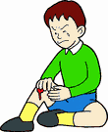 Preventing Children’s Sports injuries
- How Can Sports Injuries Be Prevented?
Some experts estimate that half of children's injuries that occur during organized sports activities are preventable. You can help prevent sports injuries in your child by following some simple guidelines:
- Use of proper equipment
Proper equipment that is the correct size and carefully fitted for your child is essential for injury prevention. In addition, children should wear safety gear that is appropriate to the specific sport. For example, your child should wear helmets with shatterproof polycarbonate shields for baseball, softball, bicycle riding, and hockey. Helmets should also be worn when in-line skating or riding scooters and skateboards. Protective eyewear (for example, shatterproof goggles) should be worn during racquet sports and for basketball. Ask your child's coach about appropriate helmets, shoes, mouth guards, athletic cups and supporters, and padding.
Protective equipment should be approved by an appropriate certifying organization. Hockey face masks should be approved by the Hockey Equipment Certification Council (HECC) or the Canadian Standards Association (CSA). Sports goggles should be approved by the American Society of Testing and Materials (ASTM) or pass the racket sport standards of the CSA. Bicycle helmets should have a safety certification sticker from the Consumer Product Safety Commission (CPSC) or the Snell Memorial Foundation.
Athletic equipment should also be safety-oriented. For example, newer "breakaway" bases that move when hit by a sliding player have been effective in reducing leg injuries caused by sliding into a base. Also, all equipment should be properly maintained to ensure its effectiveness.
- Maintenance and appropriateness of playing surfaces
Check that playing fields are not full of holes and ruts, possibly causing the child to fall. Basketball courts and running tracks should not be concrete.
- Adequate adult supervision and commitment to safety
Any team sport or activity that your child participates in should be supervised by qualified adults. Select leagues and teams that have the same commitment to safety and injury prevention that you do. The team coach should have training in first aid and CPR, and the coach's philosophy should promote players' wellbeing. For example, a coach with a win-at-all-costs attitude may encourage children to play through injury and may not encourage good sportsmanship. Be sure that the coach enforces playing rules and requires that safety equipment be used at all times. Additionally, make sure that children are matched for sports according to their skill level, size, and physical and emotional maturity.
 Preventing Children’s Sports injuries
- Proper preparation of child athletes
You wouldn't send a child who can't swim to a swimming pool, so you shouldn't send a child to play a sport that he is unprepared to play. Make sure the child knows how to play the sport before putting him out on the field. Your child should be adequately prepared with warm-ups and training sessions before practices as well as before games. Proper preparation will help ensure that your child has fun and reduces the chances of an injury. In addition, your child should drink plenty of fluids and be allowed to rest during practices and games.
- What Are Some Common Types of Sports Injuries?
Sometimes, despite your best efforts to prevent your child from getting hurt while playing sports, an injury may occur. Three common types of sports injuries in children are acute injuries, overuse injuries, and re-injuries.
Acute Injuries
Acute injuries occur suddenly and are usually associated with some form of trauma. In younger children, acute injuries typically include minor bruises, sprains, and strains. Teen athletes are more likely to sustain more severe injuries, including broken bones and torn ligaments.
More severe acute injuries that can occur, regardless of age, include:
- eye injuries, including scratched corneas, detached retinas, and blood in the eye
- broken bones
- brain injuries, including concussions, skull fractures, brain hemorrhages, and spinal cord injuries
Acute injuries often occur because of a lack of proper equipment or using improper equipment. For example, without protective eyewear, eye injuries are extremely common in basketball and racquet sports. In addition, many children playing baseball and softball have suffered broken legs or ankles from sliding into immobile bases.
Overuse Injuries
Overuse injuries occur from repetitive actions that put too much stress on the musculoskeletal system. Although these injuries can occur in adults as well as children, they are more problematic in a child athlete because of the effect they may have on your child's bone growth. Any child who plays sports can develop overuse injuries, although the more time your child spends on the sport, the more likely your child is to experience an overuse injury.

 Preventing Children’s Sports injuries
Some of the most common types of overuse injuries are:
- anterior knee pain
Anterior knee pain is pain in the front of the knee under the kneecap. The knee will be sore and swollen due to tendon or cartilage inflammation. The cause is most commonly muscle tightness in the hamstrings or quadriceps.
- Little League elbow
Repetitive throwing sometimes results in pain and tenderness in the elbow. The ability to flex and extend the arm may be affected.
- swimmer's shoulder
Swimmer's shoulder is an inflammation (swelling) of the shoulder caused by the repeated stress of the overhead motion associated with swimming or throwing a ball. The pain typically begins intermittently but may progress to continuous pain.
- shin splints
Shin splints are characterized by pain and discomfort on the front of the lower parts of the legs, often caused by repeated running on a hard surface.
- Spondylolysis
Spondylolysis often resulting from trauma or from repetitive overextension, twisting, or compression of the back muscles causes persistent lower back pain. Spondylolysis is commonly seen in football, weight lifting, gymnastics, wrestling, and diving, and is more common in girls than boys.
Overuse injuries can be caused or aggravated by:
- growth spurts
- inadequate warm up
- excessive activity (for example, increased intensity, duration, or frequency of playing and/or training)
- improper technique (for example, overextending on a pitch)
- unsuitable equipment (for example, non-supportive athletic shoes)
Re-injuries
Another common sports injury is re-injury. Re-injury occurs when an athlete returns to the sport before a previous injury has sufficiently healed. Although an injured athlete may want to return to the game prematurely, an athlete is at a much greater risk for re-injury when recovery isn't complete. Returning to the playing field before a previous injury has completely healed places stress upon the injury and forces the body to compensate for the weakness, which may put the athlete at greater risk for injuring another body part. Re-injury can be avoided by allowing the injury to completely heal. Once your child's doctor has approved him to return to his sport, make sure that he prevents re-injury by properly warming up and cooling down during exercise. Your child should also pace himself because sudden exertion can cause re-injury. Explain to your child that easing back into his sport at a sensible pace is better than returning to the hospital!
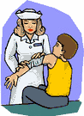 How are Sports Injuries Treated
Treatment of sports injuries varies by the type of injury and whether the injury is acute or from overuse. For acute injuries, most pediatric sports medicine specialists advocate a "better safe than sorry" approach. If an injury appears to affect function in any way - for example, if the child can't bend his finger, is limping, or has had a change in consciousness - first aid should be administered immediately. A pediatrician or family physician should then see the child. If the injury is severe, the child should be taken to the nearest hospital emergency department. In the case of an eye injury, immediately take the child to an ophthalmologist (eye doctor) or the hospital emergency department.
For overuse injuries, the philosophy is similar. If a child begins complaining of pain, it's the body's way of saying there's a problem. Have the child examined by a pediatrician or family physician, who can then determine whether it's necessary to see a sports medicine specialist.
Prompt diagnosis and treatment of overuse injuries are crucial to prevent the development of a chronic problem. Modifying or temporarily eliminating the activity to limit stress on the body is the main therapy for overuse injuries. In some cases, the child may not be able to resume the sport without risking further injury. Since overuse injuries are characterized by swelling, treatment may include medications to help reduce inflammation and physical therapy. When recovery is complete, adjustment in the child's technique and/or training schedule may be necessary to prevent recurrence of the injury.

Safety Code

What is ASAP?
The ASAP (A Safety Awareness Program) was introduced with the intention of emphasizing the position of the Safety Director. His goal is to provide awareness through education and information, to create a safer and healthier environment for the participants of Little League Baseball.
“Safety Focus” and injury Prevention
- Safety should always be “first and foremost”
- No games should be held when weather or field conditions are deteriorated (i.e. weather or lighting).
- Area on and around the field must be inspected for, holes, damage, stones, glass and other foreign matter.
- All team equipment must be kept in an orderly fashion in the dugout area, and not to be involved in the field of play.
- Only Players, Managers, and Coaches are permitted in the dugout during games and practice sessions.
- All Managers and coaches must be Rutgers Certified, and a copy will be kept on league file.
- All Managers and Coaches must attend Coaches Clinics provided by the Elmwood Park Little League. The Coaches Clinic will be held on Thursday March 14, 2019 in the EPHS Gym. It is mandatory for all Coaches and Officers to attend. (See Appendix F)
- A Municipal Ordinance has been passed for Mandatory finger printing. All Volunteers must be finger printed prior to every season.
- All Managers, Coaches, and Concession Staff members must attend a First-aid Training Course. EPLL has planned a First Aid Training Session for all League Volunteers. It will be provided by the EP Volunteer Ambulance Corps and Joe Marsh Elmwood Park LL Safety Officer. The Date is Thursday March 21st 7:00 @ the EP Recreation Center Dining Room.
- A CPR Certification Session and Defibrillator training will be scheduled in addition to the First Aid Training. When a date, time, and place are set, a communication will be sent to all Officers, Managers, Coaches, and volunteers. A fee ill be encored by each participant.
- Players at all levels are required to wear a protective cup during practice and games. If this is not adhered to by the players the coaches have been instructed to not permit the player to enter the field for practice or a game.
- Catchers must wear full Little League approved Gear while on the field for practice, games and warm-ups. All catchers’ masks must have a throat guard.
- During games and practices no food permitted in the dugouts
- EPLL Rules prohibit “GUM CHEWING” during games and practices.
- No “horse play” wile on the field for practice or games.
- All pre-game warm-ups must be performed within the confines of the field.
- No head first sliding except when runner is returning to the base.
- Equipment must be checked on a regular basis, and worn or damaged items must be returned for replacement.
- Players requiring glasses should be encouraged to wear Sports or Safety Glasses.
- Jewelry (i.e. ear rings, necklaces, bracelets, watches) will not be worn during games.

Safety Tips

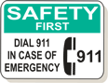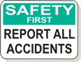

If A Victim is Choking

Partial Obstruction with Good Air Exchange
Symptoms:

- Forceful cough with wheezing sounds between coughs.
Treatment:
- Encourage victim to cough as long as good air exchange continues.
- DO NOT interfere with attempts to expel object.

Partial or Complete Airway Obstruction in
Conscious Victim
Symptoms:
- Weak cough, high-pitched crowing noises during inhalation, inability to breathe, cough or speak, gesture of clutching neck between thumb and index finger, exaggerated breathing efforts, dusky or bluish skin color.
Treatment: The Heimlich Maneuver:
- Stand behind the victim.
- Reach around victim with both arms under the victim’s arms.
- Place thumb side of fist against middle of abdomen just above the navel. Grasp fist with other hand.
- Give quick, upward thrusts.
- Repeat until object is coughed up.
Safety Tips
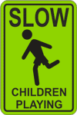
☺ Do’s
- Reassure and aid children who are injured
- Know your limitations
- Assist those who require medical attention with the Look, Listen, and Feel motto:
    - Look for signs of injury
    - Listen to the injured and have them describe what issues they may have
    - Feel carefully the injured area for signs of swelling, discoloration, or bleeding
- Be sure to have all players Medical Clearance Forms at practices and games
- Have players drink plenty of water or sports drinks during practices and games
- Make arrangements to have a means of communication (Cell or Public Phone) available when at a game or practice.

☹ Don’ts
- Administer any Medication
- Allow any player to continue to participate with an open wound. The wound should be bandaged before reentering.
- Provide any food during games or practices
- Move or transport individuals unless absolutely necessary
- Leave a child unattended at a game or practice
- Hesitate to report any potential Safety Hazards to the Safety Director or any other League Official.
Lightning and Storm Safety

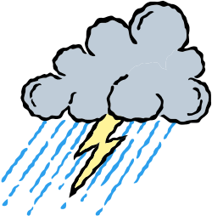
Important Facts to Remember
- The average Lightning Bolt is 6-8 miles long
- The average Thunder Storm is 6-10 miles wide
- On the average, thunder can only be heard over a distance of 3-4 miles, depending on humidity, and terrain.
Determining how far away a Storm actually is!
- Once Lightning is spotted, a person can count from 1001, 1002, 1003, etc. until they hear the Thunder.
- The numbers indicate miles away.
- Play should be halted if the number is less than 1500

The truth about lightning is that it is unpredictable and
can not be prevented. A Manager, Coach, or Umpire that feels threatened by an approaching storm, should stop play and get the players to a safe environment.

The Borough of Elmwood Park is equipped with Lightning Sensors at the following complexes:
- Boro/Juniors Seniors Complex
- Gilbert Ave Complex

The Sensors work as follows:
  - A Flashing light and a Long Horn Blast from the Sensors indicate Lightning has been detected. Clear the field and escort players to safe shelter.
  - After the storm has passed, “3 All Clear Horn Blasts” will sound. Once 15 minutes has passed after these blasts have sounded, the players may return to the field. Play may resume at this point.

Concession Stand Guidelines
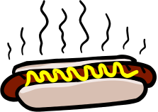
All Kitchen staff must have a valid Food Handlers License
issued by the Elmwood Park Board of Health.
1. Menu. Keep your menu simple, and keep potentially hazardous foods (meats, eggs, dairy products, protein salads, cut fruits and vegetables, etc.) to a minimum. Avoid using precooked foods or leftovers. Use only foods from approved sources, avoiding foods that have been prepared at home. Complete control over your food, from source to service, is the key to safe, sanitary food service.
2. Cooking. Use a food thermometer to check on cooking and holding temperatures of potentially
hazardous foods. All potentially hazardous foods should be kept at 41º F or below (if cold) or 140º F or above (if hot). Ground beef and ground pork products should be cooked to an internal temperature of 155º F; poultry
parts should be cooked to 165º F. Most food born illnesses from temporary events can be traced back to
lapses in temperature control.
3. Reheating. Rapidly reheat potentially hazardous foods to 165º F. Do not attempt to heat foods in crock
pots, steam tables, over sterno units or other holding devices. Slow-cooking mechanisms may activate
bacteria and never reach killing temperatures.
4. Cooling and Cold Storage. Foods that require refrigeration must be cooled to 41º F as quickly as
possible and held at that temperature until ready to serve. To cool foods down quickly, use an ice water bath
(60% ice to 40% water), stirring the product frequently, or place the food in shallow pans no more than 4 inches in depth and refrigerate. Pans should not be stored one atop the other and lids should be off or ajar until the food is completely cooled. Check the temperature periodically to see if the food is cooling properly. Allowing hazardous foods to remain unrefrigerated for too long has been the number ONE cause of food borne illness.
5. Hand Washing. Frequent and thorough hand washing remains the first line of defense in
preventing food borne disease. The use of disposable gloves can provide an additional barrier to
contamination, but they are no substitute for hand washing!
6. Health and Hygiene. Only healthy workers should prepare and serve food. Anyone who shows symptoms of disease (cramps, nausea, fever, vomiting, diarrhea, jaundice, etc.) or who has open sores or infected cuts on the hands should not be allowed in the food concession area. Workers should wear clean outer garments and should not smoke in the concession area. The use of hair restraints is recommended to prevent hair ending up in food products.
7. Food Handling. Avoid hand contact with raw, ready-to eat foods and food contact surfaces. Use an
acceptable dispensing utensil to serve food. Touching food with bare hands can transfer germs to food.
8. Dishwashing. Use disposable utensils for food service. Keep your hands away from food contact
surfaces, and never reuse disposable dishware. Ideally, dishes and utensils should be washed in a four-step
process:
1. Washing in hot soapy water;
2. Rinsing in clean water;
3. Chemical or heat sanitizing; and
4. Air drying.
9. Ice. Ice used to cool cans/bottles should not be used in cup beverages and should be stored separately. Use a scoop to dispense ice; never use the hands. Ice can become contaminated with bacteria and viruses and cause food borne illness.
10. Wiping Cloths. Rinse and store your wiping cloths in a bucket of sanitizer (example: 1 gallon of water and ½ teaspoon of chlorine bleach). Change the solution every two hours. Well-sanitized work surfaces prevent cross contamination and discourage flies.
11. Insect Control and Waste. Keep foods covered to protect them from insects. Store pesticides away from foods. Place garbage and paper wastes in a refuse container with a tight-fitting lid. Dispose of wastewater in an approved method (do not dump it outside). All water
used should be potable water from an approved source.
12. Food Storage and Cleanliness. Keep foods stored off the floor at least six inches. After your event is
finished, clean the concession area and discard unusable food.

Accident Reporting Policy 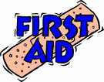

- What to report - An incident that causes any player, manager, coach, umpire, or volunteer to receive medical treatment and/or first aid must be reported to the Safety Director.

- When to report - All such incidents described above must be reported to the Safety Director within 48 hours of the incident. The Safety Director for 2019 is Joe Marsh, and he can be reached at the following:
Cell Phone: (862) 219-8466
Email: jmarsh@garfieldpolice.org

- How to make the report - reporting incidents can come in a variety of forms. Most typically, they are telephone conversations. At a minimum, the following information must be provided:
- The name and phone number of the individual involved
- The date, time, and location of the incident
- As detailed a description of the incident as possible
- The preliminary estimation of the extent of any injuries
- The name and phone number of the person reporting the incident.

Safety Director Responsibilities
- Within 48 hours of receiving the incident report, the Safety Director will contact the injured party or the party’s parents.
- Verify the information received
- Obtain any other information deemed necessary
- And check on the status of the injured party.

- If the extent of the injuries are more than minor in nature, the Safety Director shall periodically call the injured party
- Check on the status of any injuries
- Check if any other assistance is necessary in areas such as submission of insurance forms, etc. until such time as the incident is considered “closed” (i.e. no further claims are expected and/or the individual is participating in the league again).
- See Appendix D for Incident and Injury Form

**Remember, safety is everyone’s job.
**Prevention is the key to reducing accidents to a minimum.
**Don’t play on a field that is not safe or with unsafe playing equipment.
**Report all hazardous conditions to the Director of Safety or another Board member immediately.
**Be sure your players are fully equipped at all times, especially catchers and batters. And, check your team’s equipment often.

Safety Mission Statement



Safety is never an accident!

It is always the result of high
intention, sincere effort,
intelligent direction and
skillful execution.

It represents the wise choice
of many alternatives.

Elmwood Park Little League
Boro Field

- Route 46 East to light for Boulevard Elmwood Park
- Go through Light and take 1st exit immediately after you go through the light. Take the exit around and it will take you across Route 46.
- At this time you will be on the Boulevard heading North.
- Travel approximately 1 mile to the 1st Traffic Light. This will be the intersection of “Boulevard and Market Street”.
- Go through the light and the Elmwood Park Recreation Center Building will be on the “left”. If you get to the second Traffic light you have gone too far.
- Pull into the Parking Lot between the Recreation Center and the Baseball Building. The Baseball field is behind the Recreation Center.

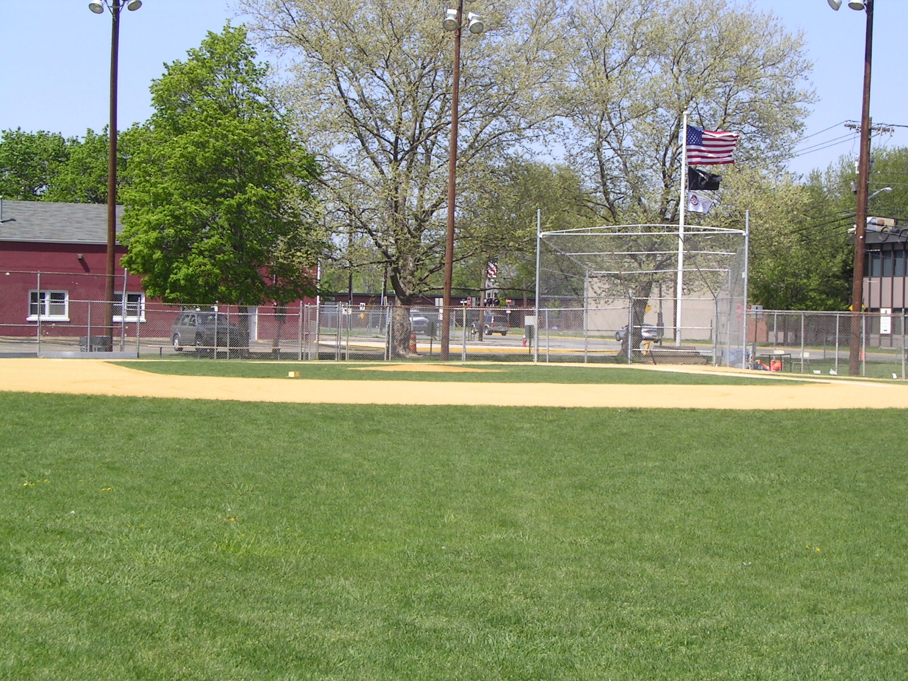

Elmwood Park Little League
Juniors/ Seniors Field

- Interstate 80 East to “Exit 61”
- At bottom of Exit Ramp stay in Left Lane to traffic light
- Make left turn at Traffic Light onto River Road
- Go under overpass to Traffic Light (Market Street)
- Make right turn on to Market Street heading East
- Travel approximately ¾ mile to Traffic Light
- Go through Traffic Light to the 2nd Left turn (Pine Street)
- Make left on to Pine Street and the Senior Field will be on your right side.

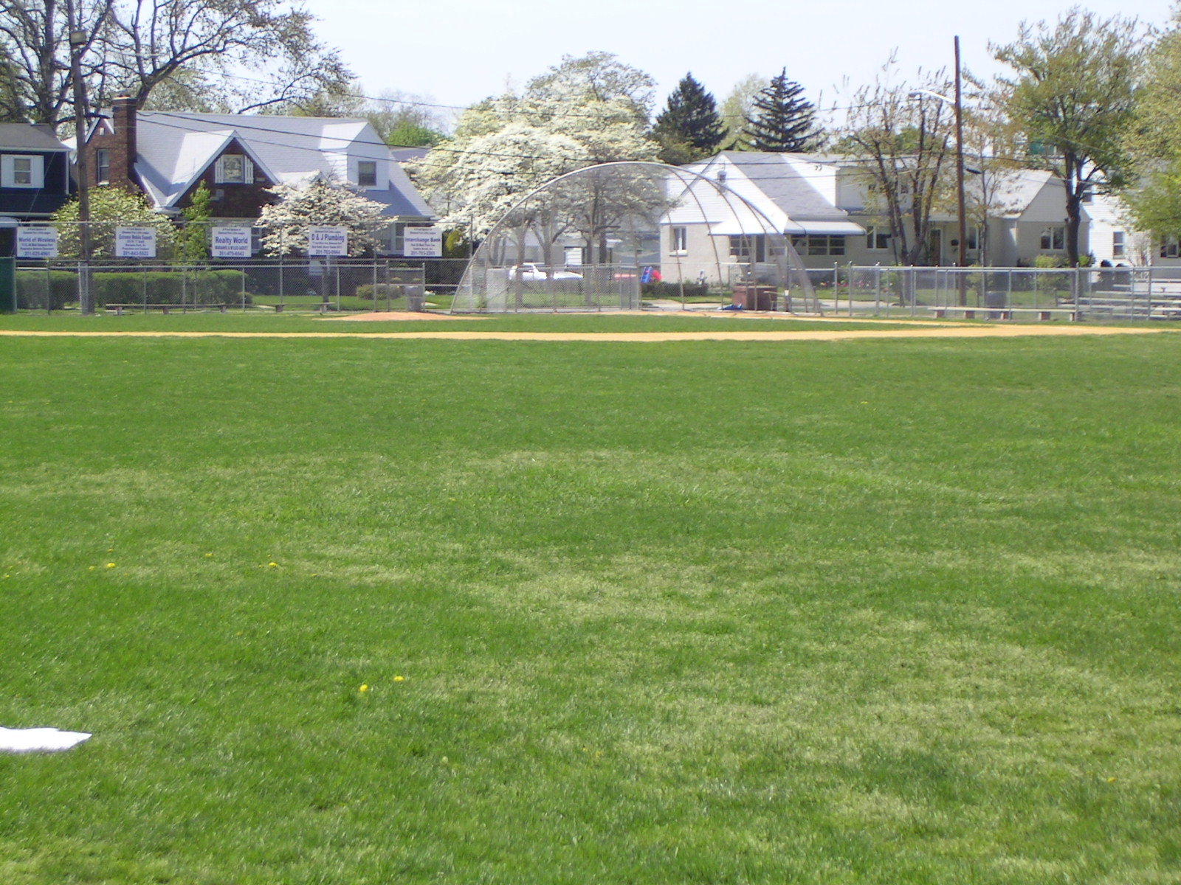

Elmwood Park Little League
Gilbert Fields
- Route 46 East
- To Traffic Light for Elmwood Park Boulevard (Be sure to stay in right hand Lane)
- Go through Light and take 1st exit immediately after you go through the light. Take the exit around and it will take you across Route 46.
- At this time you will be on the Boulevard heading North.
- Travel approximately 1 mile to the 1st Traffic Light. This will be the intersection of “Boulevard and Market Street”.
- Travel to the next Traffic Light (Molnar Drive)
- Go through the light at Molnar Drive and continue on the Boulevard
- Approximately ½ mile make left on Gilbert Ave
- Fields will be on your left across from Elementary School

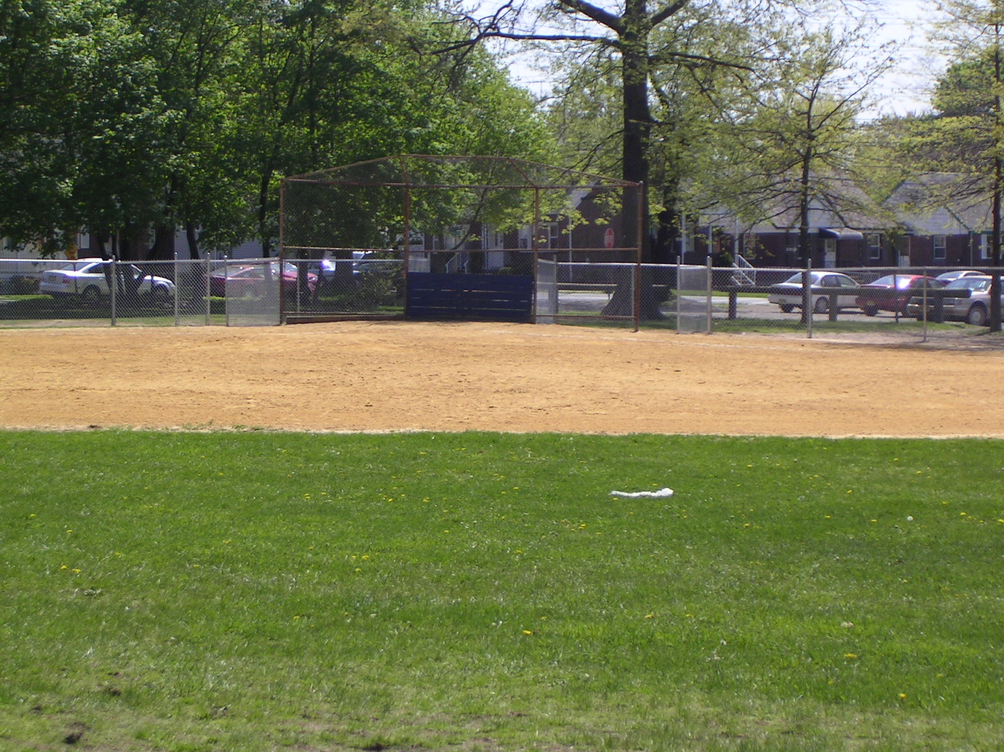
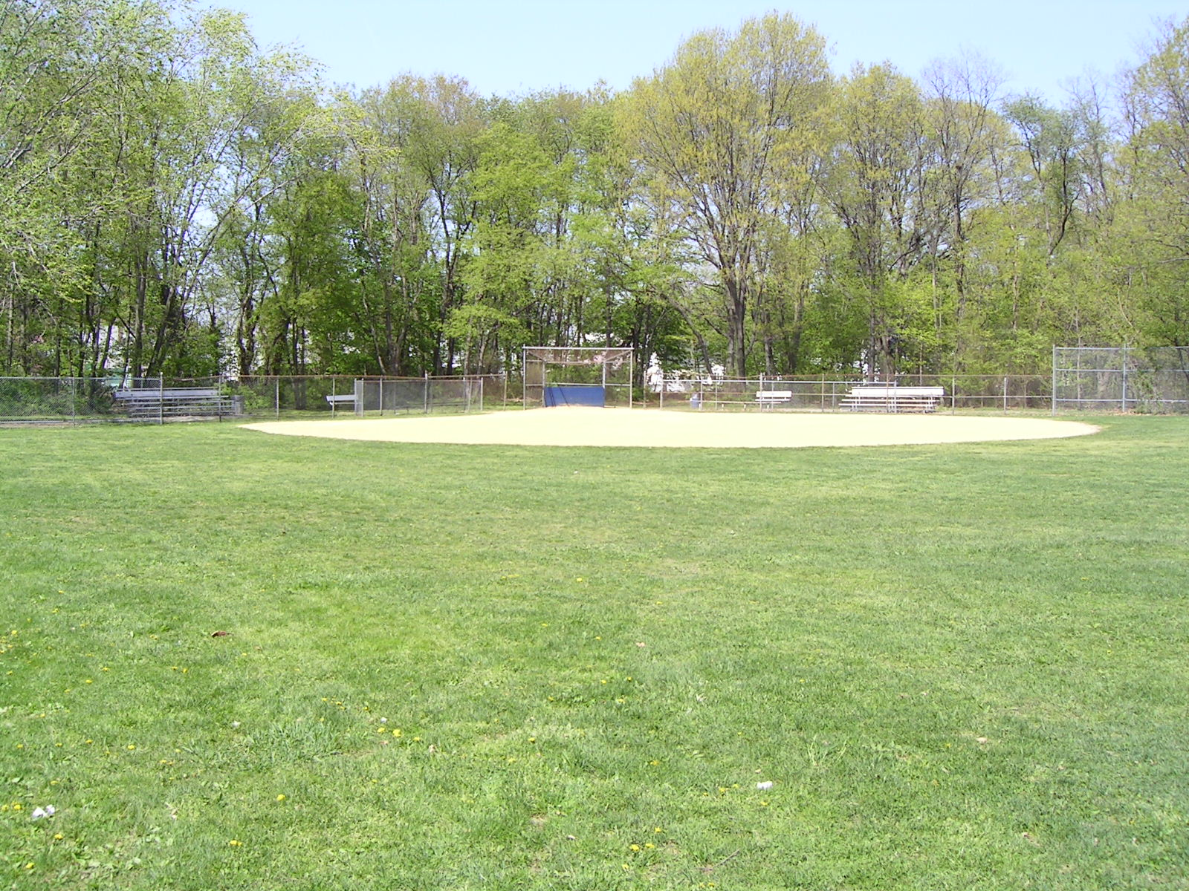

Elmwood Park Little League
Gall Ave
- Route 46 East
- To Traffic Light for Elmwood Park Boulevard (Be sure to stay in right hand Lane)
- Go through Light and take 1st exit immediately after you go through the light. Take the exit around and it will take you across Route 46.
- At this time you will be on the Boulevard heading North.
- Travel approximately 1 mile to the 1st Traffic Light. This will be the intersection of “Boulevard and Market Street”.
- Travel to the next Traffic Light (Molnar Drive)
- Make right turn on Molnar Drive
- Approximately 1/8th mile make left on Linden Ave
- Then make right turn on Gall Ave
- Field will be on your right
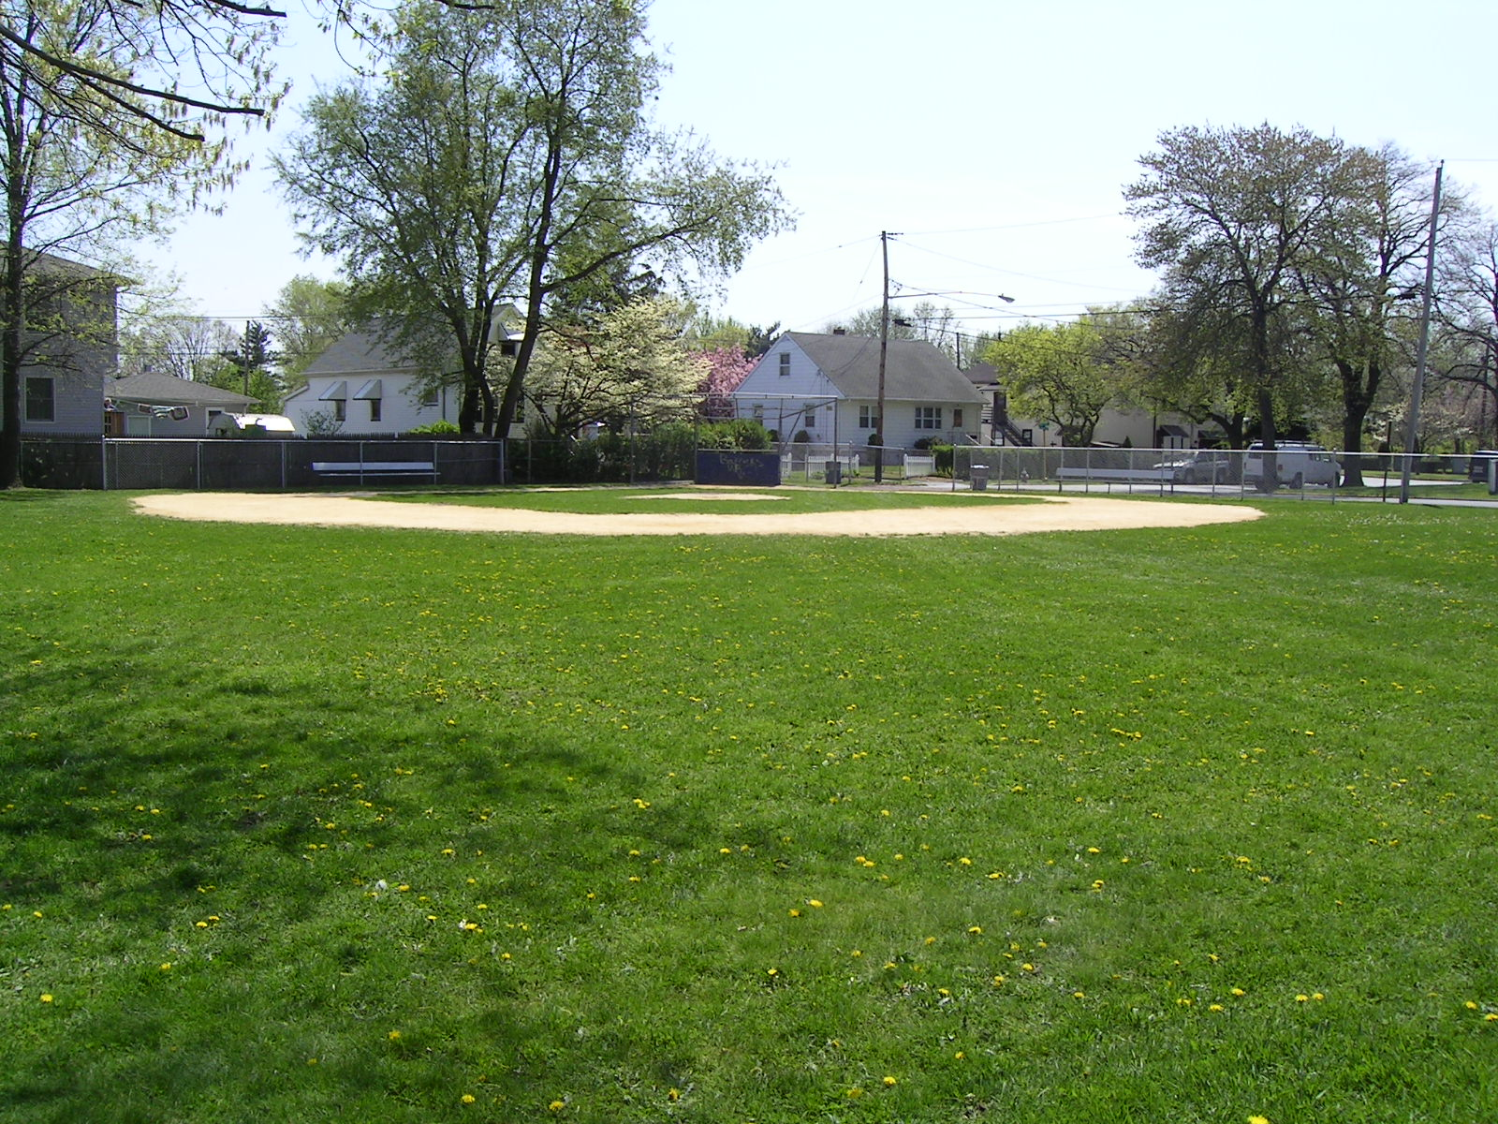

Appendix A
“2017” Field Survey

Appendix A continued
“2017” Field Survey

Appendix A continued
“2017” Field Survey

Appendix A continued
“2017” Field Survey

Appendix A continued
“2017” Field Survey

Appendix B
2017 Volunteer Form
Appendix C
2017 Player Registration Form

Appendix D
2017 Player Medical Release Form

Appendix E
2017 Player Incident Form

Appendix E
2017 Player Injury Form

Appendix F
2017 Internet Photo Release Form

Appendix G
Coaches Training Clinics

Complete Performance Baseball Academy

22 Commerce Rd. Fairfield, New Jersey

Elmwood Park Little League

P.O. BOX 581
ELMWOOD PARK, NJ 07407
201-791-2054

E-mail: eplittleleague1@hotmail.com

www.eplittleleague.com

